BCBSM Online Visits (Therapy/Counseling)

- Sign up for an account at https://bcbsmonlinevisits.com or download the app, BCBSM Online Visits App. It is recommended that use your personal email, not your HSC email so that the appointment confirmation link is on a device you can access anywhere.

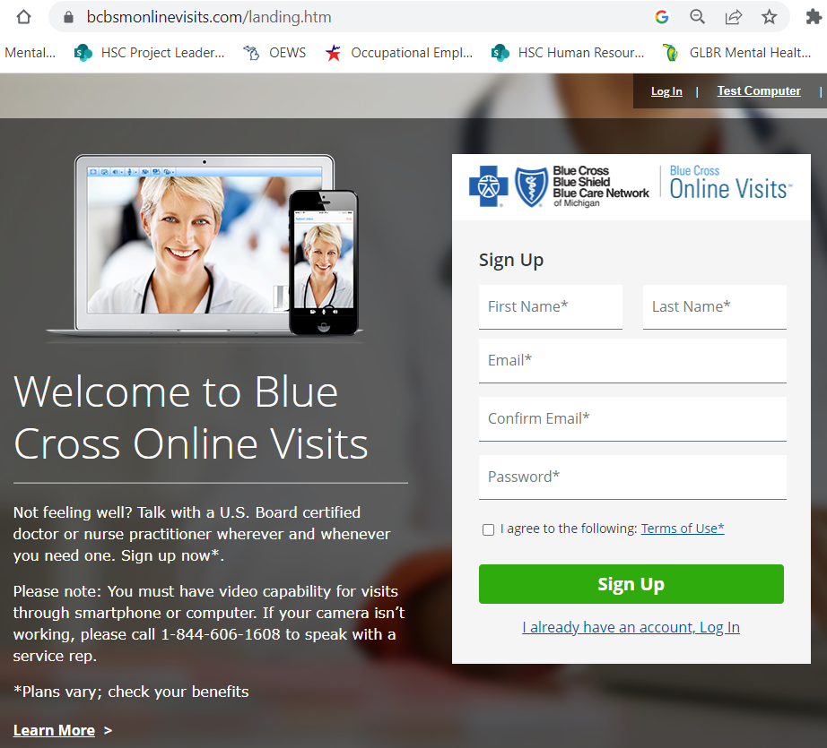

- Select Therapy (counselor) or Psychiatry (doctor).

- Schedule an appointment with the person of your choice (counselors have biographies available) and watch for an email confirmation.
- The $40 cancellation fee will only be charged if you cancel the appointment without 24-hour notice. You can use your HSA debit card or other card for payment.

- Click on the Get Started link 10-15 minutes before your appointment time.

